Adventure Works Internet Sales:
Analysis and Growth Strategy

Case Study Report, Assignment 2
Prepared for the Leadership of Adventure Works Bicycle Company

Qingan Xu
MSSP 6070
30 October 2026

Executive Summary
Adventure Works can grow Internet sales fastest by selling more to the bike buyers it already has, not by targeting customers by demographics such as home ownership. Leadership asked for an analysis of the company's Internet sales and a strategy to grow them, so this report analyzes all 60,398 order lines in InternetSales.csv. They cover 27,659 orders from 18,484 customers in six country regions, worth $29.36 million, placed from 29 December 2010 to 28 January 2014.
The four questions have clear answers:
- Sales by year and country region (Question 1). Sales fell 17.4% in 2012, from $7.08 million to $5.84 million, then rose 179.9% to $16.35 million in 2013. The United States ($9.39 million, 32.0%) and Australia ($9.06 million, 30.9%) produce 63% of all sales.
- Yearly income by gender and country region (Question 2). Within each country, the mean incomes of men and women differ by less than $2,000. Between countries the gap is wide, from $64,339 in Australia to $35,762 in France.
- Average price in the top category (Question 3). Bikes produce 96.5% of Internet sales, and the average bike sold online cost $1,862.42.
- Home ownership (Question 4). Homeowners spend $130.51 (8.7%) more per customer. The difference is statistically significant but very small (Cohen's d = 0.06), and it does not exist in the United States or Australia.
Growth depends on repeat bike buyers. Customers who bought their first bike in 2010–2012 produced 64.0% of 2013 sales when they came back for a second bike, but nine in ten of them have already returned. The next wave is the 3,677 customers who bought their first bike in 2013.
I recommend a bike-customer program with three parts: a second-bike offer for the 2013 first-time buyers, accessory bundles on every bike order, and first-bike offers for the 9,352 customers who have never bought a bike, led by the United States. Under moderate assumptions it would add about $4.85 million in sales and $2.04 million in gross profit as those customers buy over the next one to two years, equal to 29.7% of 2013 sales. Each part should be tested against a control group.

Introduction
Adventure Works Bicycle Company, the fictitious company in Microsoft's AdventureWorks sample databases, sells bikes, accessories and clothing online to customers in Australia, Canada, France, Germany, the United Kingdom and the United States. Its leadership wants to understand the company's Internet sales in order to develop a strategy for growing the business. As an analyst for Adventure Works, I summarized Internet sales by year and product category and answered four questions from leadership:
- What are the Internet sales of Adventure Works by year for each country region?
- What are the summary statistics, including the minimum, maximum and standard deviation, of yearly income by gender and country region?
- What is the average price of the product category that generates the most sales?
- Does owning a home make a difference in sales?
The current situation calls for a plan. Internet sales fell 17.4% in 2012, then rose 179.9% in 2013, to $16.35 million, after the online range expanded. By January 2014, however, most of the customers behind that surge had already made their repeat purchase, so leadership needs to know where the next growth will come from.
The evidence is the course data file InternetSales.csv, an extract of the Internet sales tables in Microsoft's AdventureWorksDW sample data warehouse (Microsoft). Each of its 60,398 rows is one order line: a single product on a single order. Its 60 columns describe the order, the product and the customer, including income, gender, home ownership, family, cars, education and commute distance (see app. A).
All calculations are in the accompanying Jupyter notebook, written in Python with pandas (McKinney), NumPy (Harris et al.), SciPy (Virtanen et al.) and Matplotlib (Hunter). It runs from top to bottom in Google Colab or Jupyter with no setup: if InternetSales.csv is not in its folder, it downloads the identical file from the project's public GitHub repository. It reproduces every number, table and figure in this report.

Key Issues, Goals, and Problems
Adventure Works' goal is to grow Internet sales and gross profit after three volatile years. Five issues stand in the way:
- Revenue follows price mix, not volume. In 2012 the store sold 47.5% more bikes than in 2011, yet bike revenue fell 17.5% because the average bike price dropped 44.1% when premium models were retired.
- The 2013 surge was largely a one-time wave. Customers who first bought in 2010–2012 produced 64.0% of 2013 sales by returning for a second bike, and 90.2% of them have already returned.
- Most new customers are low-value. Of the 12,523 new customers in 2013, 8,846 bought only accessories or clothing, spending $66 each. None of the 9,352 customers whose first order had no bike has bought one since.
- Sales are concentrated and uneven. The United States and Australia produce 63% of sales, but a US customer spends $1,201 on average, against $2,523 in Australia.
- It is unclear which customer traits matter. Income, gender and home ownership are easy to target, but the data must show whether they actually predict spending.

Decision Criteria
I judge each growth strategy against five criteria:
- Sales potential: the Internet sales it can add over the next one to two years.
- Profitability: the gross profit on those sales, at the margins observed in the data (40.6% on bikes, 62.6% on accessories and 40.1% on clothing).
- Strength of evidence: how directly past customer behavior in the data supports the expected response.
- Speed and cost: whether it works through customers already on file, whose purchase history and contact details Adventure Works holds, or needs new traffic that must be bought.
- Measurability: whether its results can be tested against a control group before it is scaled up.

Assumptions
The analysis rests on five assumptions:
- All amounts are in US dollars. Each product has the same price whatever currency the customer used, so amounts are treated as US dollars.
- The file is complete. It holds every Internet order line for the period, and each customer's profile (income, home ownership and so on) is current as of the extract.
- Product categories can be derived from product names. The file has no category column, so each product is assigned to Bikes, Accessories or Clothing from its name, following Adventure Works' product hierarchy.
- Gross profit is sales minus product cost. Marketing, shipping and other costs are not in the file.
- Past repeat behavior is a guide to the future. Customers who bought their first bike in 2013 will respond to new models and offers roughly as earlier bike buyers did.

Limitations of the Data
The data are clean and internally consistent: no duplicate rows, a quantity of one and no discount on every line, and sales equal to unit price throughout. Their limits lie in what they leave out:
- Fictitious data. The assignment describes the data set as fictitious and provided for learning only, so no conclusions about a real company are valid; the findings illustrate an analytical approach.
- Partial years. 2010 covers only 29–31 December and 2014 only 1–28 January, so year-over-year comparisons use the full years 2011–2013.
- Buyers only. The file has nothing on website visitors who did not buy, marketing spend, returns, or costs other than product cost. It cannot measure conversion rates or the return on a campaign, and Question 4 can compare only customers who already bought something.
- No product categories. Categories had to be derived from product names (see app. A).
- Empty fields. CarrierTrackingNumber and CustomerPONumber are empty, and Title, Suffix and AddressLine2 are almost entirely blank. None is needed here.
- Coarse customer data. Income is recorded in $10,000 bands, and each customer has a single profile, so changes such as a move or a new car are invisible.
- Observational data. The results show which customers spend more, not what would make a customer spend more, so the recommended program must be tested.
- A short history for the newest customers. The data end on 28 January 2014, so customers who first bought in 2013 have had little time to return.

Data Analysis
This section answers the four questions in order, summarizing sales by year and product category with Question 3, then examines where growth comes from. Supplementary material is in the appendices, and the full code is in the notebook.

Question 1: Internet Sales by Year for Each Country Region
Internet sales total $29,358,677 for the whole period (see table 1). They fell 17.4% in 2012, from $7,075,526 to $5,842,485, then rose 179.9% to $16,351,550 in 2013. The United States and Australia together produce 63% of sales, followed by the United Kingdom, Germany, France and Canada.
Table 1
Internet Sales by Country Region and Year (US$ Thousands)
Country region | 2010* | 2011 | 2012 | 2013 | 2014* | Total | Share | 2012 vs. 2011 | 2013 vs. 2012
United States | 15 | 2,458 | 1,437 | 5,462 | 18 | 9,390 | 32.0% | −41.5% | +280.1%
Australia | 21 | 2,564 | 2,128 | 4,339 | 9 | 9,061 | 30.9% | −17.0% | +103.9%
United Kingdom | 1 | 551 | 713 | 2,124 | 4 | 3,392 | 11.6% | +29.4% | +198.0%
Germany | 0 | 521 | 609 | 1,762 | 3 | 2,894 | 9.9% | +16.9% | +189.5%
France | 3 | 411 | 648 | 1,579 | 3 | 2,644 | 9.0% | +57.7% | +143.6%
Canada | 4 | 572 | 308 | 1,086 | 9 | 1,978 | 6.7% | −46.2% | +252.9%
Total | 43 | 7,076 | 5,842 | 16,352 | 46 | 29,359 | 100.0% | −17.4% | +179.9%
Source: Author's calculations from InternetSales.csv (Microsoft). * Partial years: 2010 covers 29–31 December and 2014 covers 1–28 January. Rows may not add to totals because of rounding.
Three patterns stand out:
- The 2012 decline was confined to three markets. Sales fell in Canada (−46.2%), the United States (−41.5%) and Australia (−17.0%) but grew in France (+57.7%), the United Kingdom (+29.4%) and Germany (+16.9%).
- Every country at least doubled its sales in 2013, led by the United States (+280.1%) and Canada (+252.9%).
- The United States became the largest market only in 2013. Australia led in both 2011 and 2012.
Question 3 explains both the 2012 dip and the 2013 surge: they follow changes in the bike range rather than in demand from any one country.

Question 2: Summary Statistics for Yearly Income by Gender and Country Region
Gender makes almost no difference to income, while country makes a large one (see table 2). Within every country, the mean incomes of women and men are less than $2,000 apart, and customers are split almost evenly by gender (48.8% to 49.7% female). Income describes a customer, not an order, so each of the 18,484 customers is counted once.
Table 2
Yearly Income of Internet Customers by Country Region and Gender (US$)
Country region | Gender | Customers | Mean | Median | Std. dev. | Minimum | Maximum
Australia | Female | 1,777 | $65,284 | $70,000 | $31,164 | $10,000 | $160,000
 | Male | 1,814 | $63,412 | $70,000 | $32,451 | $10,000 | $170,000
United States | Female | 3,888 | $63,277 | $60,000 | $25,167 | $10,000 | $170,000
 | Male | 3,931 | $63,953 | $60,000 | $26,228 | $10,000 | $170,000
Canada | Female | 767 | $56,506 | $60,000 | $19,182 | $10,000 | $170,000
 | Male | 804 | $57,799 | $60,000 | $21,215 | $10,000 | $170,000
United Kingdom | Female | 934 | $52,184 | $30,000 | $48,288 | $10,000 | $170,000
 | Male | 979 | $52,155 | $30,000 | $48,593 | $10,000 | $170,000
Germany | Female | 874 | $43,810 | $30,000 | $35,716 | $10,000 | $130,000
 | Male | 906 | $42,108 | $30,000 | $35,277 | $10,000 | $130,000
France | Female | 893 | $35,342 | $30,000 | $26,916 | $10,000 | $110,000
 | Male | 917 | $36,172 | $30,000 | $27,633 | $10,000 | $110,000
Source: Author's calculations from InternetSales.csv (Microsoft). Countries are sorted by mean income; each customer is counted once.
- Australia and the United States have the highest incomes, with means of $64,339 and $63,617. Canada ($57,167), the United Kingdom ($52,169), Germany ($42,944) and France ($35,762) follow.
- Spread varies more than level. The United Kingdom has the widest spread (a standard deviation of about $48,000), and its median of $30,000 sits far below its mean. Canada has the narrowest (about $20,000).
- Every group starts at $10,000, but incomes reach $170,000 in most groups and only $130,000 in Germany and $110,000 in France.
Counting order lines instead of customers would raise every mean by $1,490 to $4,623, because higher-income customers place more order lines; table 2 avoids that bias. Income is recorded in $10,000 bands, so these statistics describe banded values.

Question 3: Sales by Year and Product Category, and the Top Category's Average Price
Bikes generate the most sales: $28,318,145, or 96.5% of Internet sales (see table 3). They were the only products sold online until 28 December 2012, so they produced all sales in 2010 and 2011 and almost all of them in 2012. Accessories and clothing added $992,048 in 2013, 6.1% of that year's sales, and in January 2014 they were the only products sold.
The average price of a bike sold online is $1,862.42, from 15,205 bikes sold. Every order line is one unit with no discount, so this is total bike sales divided by bikes sold.
Table 3
Internet Sales by Product Category and Year (US$ Thousands), with Average Price and Gross Margin
Category | 2010* | 2011 | 2012 | 2013 | 2014* | Total | Share of sales | Average price (US$) | Gross margin
Bikes | 43 | 7,076 | 5,840 | 15,360 | 0 | 28,318 | 96.5% | 1,862.42 | 40.6%
Accessories | 0 | 0 | 2 | 668 | 30 | 701 | 2.4% | 19.42 | 62.6%
Clothing | 0 | 0 | 1 | 324 | 15 | 340 | 1.2% | 37.33 | 40.1%
Total | 43 | 7,076 | 5,842 | 16,352 | 46 | 29,359 | 100.0%
Source: Author's calculations from InternetSales.csv (Microsoft). * Partial years. Average price equals sales divided by units sold; gross margin is sales minus product cost, divided by sales. Categories are derived from product names (see app. A). Rows may not add to totals because of rounding.
Bike prices range from $539.99 to $3,578.27, with a standard deviation of $944.12 (see table 4). Mountain bikes sell for the most on average, and touring bikes for the least. Averaged over the 116 bike products in the catalog, without weighting by sales, the list price is $1,542.80.
Table 4
Prices of Bikes Sold Online, by Type (US$)
Bike type | Bikes sold | Sales | Average price | Lowest price | Highest price
Mountain bikes | 4,970 | $9,952,760 | $2,002.57 | $539.99 | $3,399.99
Road bikes | 8,068 | $14,520,584 | $1,799.77 | $539.99 | $3,578.27
Touring bikes | 2,167 | $3,844,801 | $1,774.25 | $742.35 | $2,384.07
All bikes | 15,205 | $28,318,145 | $1,862.42 | $539.99 | $3,578.27
Source: Author's calculations from InternetSales.csv (Microsoft).
The bike range also explains the pattern in Question 1 (see fig. 1). Until late December 2012 the online store sold only bikes:
- The 2012 dip. At the end of December 2011, the premium Road-150 ($3,578.27) and Mountain-100 (about $3,400) were replaced by cheaper models. In 2012 the store sold 47.5% more bikes, but the average bike price fell 44.1%, from $3,192.93 to $1,786.39, so bike revenue fell 17.5%.
- The 2013 surge. On 28–30 December 2012, seven new bike models went on sale together with accessories and clothing, and monthly sales nearly tripled. In 2013 accessories and clothing sold 43,095 units but added only $0.99 million.
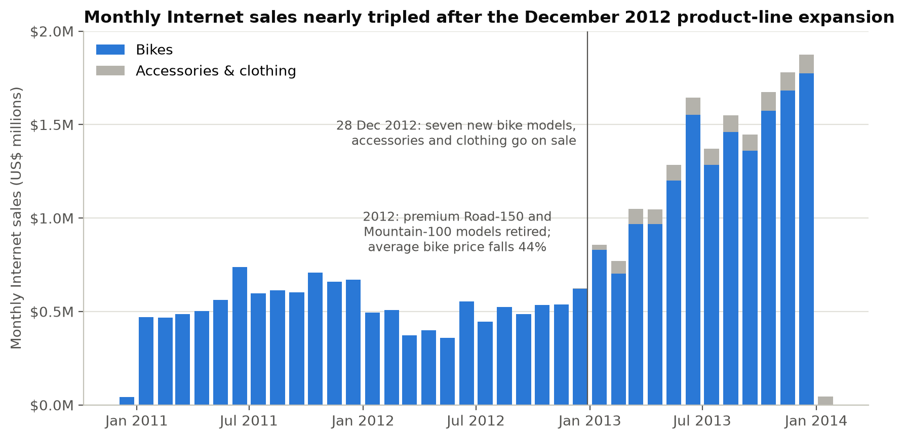
Fig. 1. Monthly Internet sales by product group, December 2010 to January 2014, with the vertical line at 28 December 2012; author's chart from InternetSales.csv (Microsoft).
Accessories earn the highest gross margin (62.6%, against 40.6% for bikes). That makes them valuable as add-ons to bike orders, even though they add little revenue on their own.

Question 4: Does Owning a Home Make a Difference in Sales?
Owning a home makes a statistically significant but small difference. Homeowners are 67.6% of customers and produce 69.4% of sales (see table 5). On average they spend $130.51 more per customer than non-homeowners (8.7% more), mainly because they place slightly more orders.
Table 5
Homeowners and Non-Homeowners Compared on Lifetime Internet Sales
Measure | Homeowners | Not homeowners
Customers | 12,502 (67.6%) | 5,982 (32.4%)
Lifetime Internet sales | $20,385,350 (69.4%) | $8,973,327 (30.6%)
Mean sales per customer | $1,630.57 | $1,500.05
Median sales per customer | $342.00 | $209.96
Orders per customer | 1.52 | 1.44
Average order value | $1,069.65 | $1,043.29
Share who bought a bike | 49.7% | 48.9%
Mean yearly income | $58,327 | $55,172
Source: Author's calculations from InternetSales.csv (Microsoft); each of the 18,484 customers is counted once.
Three checks show that the difference is real but too small to matter for targeting:
- Significance. Welch's t-test, which does not assume equal variances (Welch), gives t = 3.98 and p < 0.001, and the 95% confidence interval for the difference runs from $66 to $195. A Mann–Whitney U test, which compares ranks rather than means (Mann and Whitney), agrees (p = 0.0006).
- Size. The effect size is tiny: Cohen's d is 0.06, against the 0.2 that Cohen describes as small (Cohen). Homeowners are no more likely to buy a bike (49.7% against 48.9%; chi-square p = 0.32).
- Other differences. Homeowners also differ in income and in when they first bought. Holding those and the other customer traits constant, a homeowner spends $109.77 more (95% confidence interval $70 to $149), about 7% of the average customer's $1,588.33 (see app. C).
The difference also depends on the country (see fig. 2). There is no gap in the United States or Australia, which produce 63% of sales. The gap comes mainly from France, Germany and the United Kingdom, where homeowners were more often early customers who returned for a second bike; Canada's smaller gap ($174) is borderline (p = 0.046).
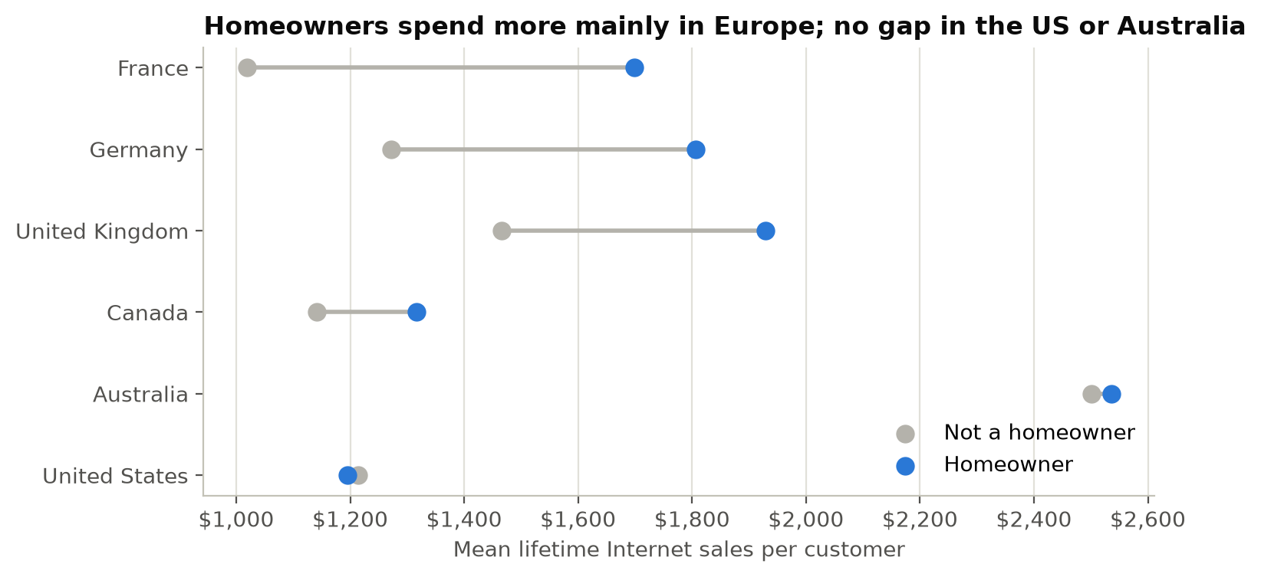
Fig. 2. Mean lifetime Internet sales per customer for homeowners and non-homeowners, by country region; author's chart from InternetSales.csv (Microsoft).
Home ownership is therefore a weak basis for targeting compared with purchase history, country or the customer traits in appendix B. And because every customer in the file already bought something, the data cannot show whether homeowners are more likely to become customers in the first place.

Where Growth Comes From
Returning bike customers drove the 2013 surge. Customers who first bought in 2010–2012 generated $10,460,817 in 2013, or 64.0% of that year's sales (see fig. 3). New bike buyers added 32.4%, and the 8,846 new customers who bought only accessories or clothing added 3.6%.
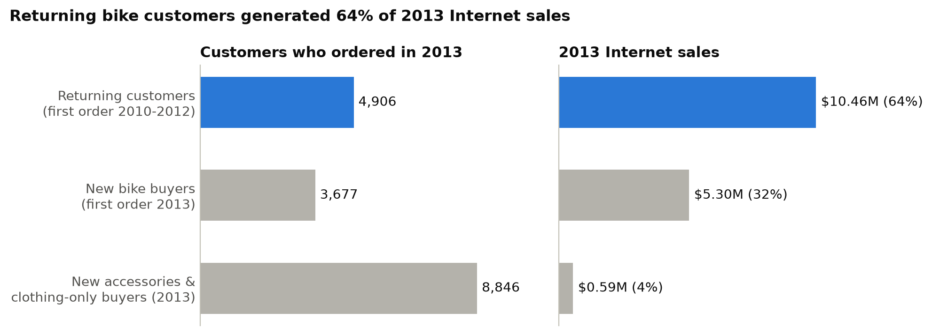
Fig. 3. Customers who ordered in 2013 and their 2013 Internet sales, by customer group; author's chart from InternetSales.csv (Microsoft).
The store's business changed shape in 2013 (see table 6). It took 21,289 orders, 6.5 times as many as in 2012, but the average order value fell from $1,787.24 to $768.08 as low-priced accessories and clothing joined the range.
Table 6
Orders and Customers by Year
Year | Orders | Active customers | New customers | Average order value | Order lines per order
2010* | 14 | 14 | 14 | $3,101.50 | 1.00
2011 | 2,216 | 2,216 | 2,216 | $3,192.93 | 1.00
2012 | 3,269 | 3,255 | 3,225 | $1,787.24 | 1.04
2013 | 21,289 | 17,429 | 12,523 | $768.08 | 2.48
2014* | 871 | 834 | 506 | $52.46 | 2.26
Source: Author's calculations from InternetSales.csv (Microsoft). * Partial years. New customers placed their first order that year.
Repeat buying explains the pattern:
- Early bike buyers came back for a second bike. Of the 5,455 customers who bought their first bike in 2010–2012, 90.2% placed a second order. Every second order came on or after 28 December 2012, when the new range went on sale, and every one included another bike (average $1,715.74, at a 41.7% gross margin).
- That wave is largely spent. With nine in ten early customers already back, future repeat sales depend on the 3,677 customers who bought their first bike in 2013. Only 2.2% have returned so far, but earlier cohorts took a median of 368 days (2012 buyers) to 673 days (2011 buyers) to come back.
- Accessories brought traffic, not bike buyers. None of the 9,352 customers whose first order had no bike has bought one since. Their average lifetime spend is $67.63, against $3,146 for bike buyers.
- Bike orders already carry add-ons, but small ones. Of the 2013 bike orders, 87.6% included accessories or clothing, worth $41.75 per bike order on average.
- The United States has the most room to grow. It has the most customers (7,819) but the lowest sales per customer ($1,201, against $2,523 in Australia). It also has the most customers who have never bought a bike (4,250) and the most first-time bike buyers in 2013 (1,932), and its early buyers returned less often (80.6%) than those in Australia (99.8%), the United Kingdom (99.1%) or Germany (96.7%).

Preferred Alternative and Rationale
I compared three growth strategies against the decision criteria (see table 7). Strategy C, selling more to bike customers, is the preferred alternative.
Table 7
Three Growth Strategies Compared against the Decision Criteria
Criterion | A. Target homeowners | B. Attract new customers with accessories and clothing | C. Sell more to bike customers
Customers reached | Homeowners, 67.6% of current customers | New website visitors | 3,677 first-time bike buyers from 2013, 9,352 customers without a bike, and about 9,700 bike orders a year
Sales potential | Low: $110 more per homeowner, other things equal | Low: $66 per new accessories-only customer in 2013 | High: second orders averaged $1,715.74
Profitability | Bike margins, but on small extra sales | 62.6% margin on accessories, but on small sales | Bike margins (40.6% to 41.7%) plus 55.3% on add-ons
Strength of evidence | Weak: tiny effect (d = 0.06), and none in the US or Australia | Weak: no customer who started without a bike has bought one | Strong: 90.2% of earlier bike buyers came back for another bike
Speed and cost | Needs new targeting data or advertising | Needs paid traffic | Uses customers and contact details already on file
Measurability | Testable, but the expected effect is small | Testable | Testable with a random holdout group
Source: Author's analysis of InternetSales.csv (Microsoft). Sales potential and evidence come from the analysis above; speed and cost are the author's judgment.
Strategy C performs best on the criteria as a whole. It targets the behavior the data shows most clearly: bike buyers return for another bike when new models appear, and their second orders are large and earn bike margins. It also works through customers Adventure Works already knows, and a control group can measure its effect cheaply.
Strategies A and B fail on evidence. Home ownership barely changes what a customer spends once other traits are known, and the gap disappears in the two largest markets. Accessories-only customers bring traffic but little revenue, and none has gone on to buy a bike. Accessories still matter in strategy C, as add-ons to bike orders, where their high margin counts.

Recommendations and Predicted Outcome
I recommend that Adventure Works take five steps:
- Run a second-bike program for the 3,677 customers who bought their first bike in 2013. Earlier buyers returned when new models went on sale, a median of one to two years after their first bike, so the program should pair each model launch with a loyalty offer to these customers.
- Bundle accessories with every bike order. Offer a helmet, bottle and tire kit at checkout to raise add-on spend above today's $41.75 per bike order.
- Make first-bike offers to the 9,352 customers who have never bought one. Start with the traits most associated with buying a bike: no car or one car, a short commute (0–1 or 2–5 miles) and ages 35 to 44 (see app. B).
- Start in the United States. It has the most customers without a bike (4,250), the most first-time bike buyers from 2013 (1,932) and the lowest sales per customer.
- Test before scaling. Hold back a random 10% of each target group as a control, and compare second-bike rates, add-on spend per bike order and first-bike conversion against it. Do not use home ownership to target offers.
The program's effect can be sized from behavior observed in the data (see table 8). Each scenario multiplies the customers reached by a response rate and by an observed value: second orders averaged $1,715.74 at a 41.7% gross margin, a bike averages $1,862.42 at 40.6%, and add-ons earn 55.3%.
Table 8
Estimated Added Sales and Gross Profit from the Recommended Program
Scenario | Second-bike rate (of 3,677 customers) | First-bike conversion (of 9,352 customers) | Extra add-on spend per bike order (9,706 orders) | Added sales | Added gross profit | Share of 2013 sales
Conservative | 40% | 2% | $10 | $2,968,911 | $1,248,687 | 18.2%
Moderate | 60% | 5% | $20 | $4,850,244 | $2,041,387 | 29.7%
Strong | 90% | 10% | $30 | $7,710,800 | $3,239,000 | 47.2%
Source: Author's calculations from InternetSales.csv (Microsoft). Added sales are one-time totals as the 2013 bike buyers return over one to two years; the bundle effect covers one year of bike orders.
Under moderate assumptions, the program would add about $4.85 million in sales and $2.04 million in gross profit. The return rate assumed, 60%, is well below the 90.2% observed for earlier bike buyers. Most of the gain comes from second bikes ($3.79 million), with $0.87 million from first-bike conversions and $0.19 million from bundles; even the conservative case adds about $3.0 million, or 18.2% of 2013 sales.
These are estimates, not forecasts. Some customers would buy again without any program, and the data cannot say how many, so the control groups in step 5 are needed to measure the program's true effect.

Conclusion
Adventure Works' Internet sales totaled $29.36 million from December 2010 to January 2014. They dipped 17.4% in 2012 when premium bikes were retired, then nearly tripled in 2013 when a new bike range, accessories and clothing went on sale. Bikes generate 96.5% of sales at an average price of $1,862.42, and the United States and Australia produce 63%.
Customer demographics explain little of this. Income varies widely between countries but hardly at all between men and women within a country, and homeowners spend only $130.51 more per customer, with no gap in the two largest markets. Purchase history explains far more: returning bike buyers produced 64.0% of 2013 sales.
Adventure Works should therefore grow by bringing bike buyers back, adding accessories to their orders and turning customers without a bike into bike buyers, starting in the United States and measuring results against control groups. Under moderate assumptions, that program would add about $4.85 million in sales.

Works Cited
Cohen, Jacob. Statistical Power Analysis for the Behavioral Sciences. 2nd ed., Lawrence Erlbaum Associates, 1988.
Harris, Charles R., et al. "Array Programming with NumPy." Nature, vol. 585, no. 7825, 2020, pp. 357–62, https://doi.org/10.1038/s41586-020-2649-2.
Hunter, John D. "Matplotlib: A 2D Graphics Environment." Computing in Science & Engineering, vol. 9, no. 3, 2007, pp. 90–95, https://doi.org/10.1109/MCSE.2007.55.
Long, J. Scott, and Laurie H. Ervin. "Using Heteroscedasticity Consistent Standard Errors in the Linear Regression Model." The American Statistician, vol. 54, no. 3, 2000, pp. 217–24, https://doi.org/10.1080/00031305.2000.10474549.
MacKinnon, James G., and Halbert White. "Some Heteroskedasticity-Consistent Covariance Matrix Estimators with Improved Finite Sample Properties." Journal of Econometrics, vol. 29, no. 3, 1985, pp. 305–25, https://doi.org/10.1016/0304-4076(85)90158-7.
Mann, H. B., and D. R. Whitney. "On a Test of Whether One of Two Random Variables Is Stochastically Larger than the Other." The Annals of Mathematical Statistics, vol. 18, no. 1, 1947, pp. 50–60, https://doi.org/10.1214/aoms/1177730491.
McKinney, Wes. "Data Structures for Statistical Computing in Python." Proceedings of the 9th Python in Science Conference, edited by Stéfan van der Walt and Jarrod Millman, 2010, pp. 56–61, https://doi.org/10.25080/Majora-92bf1922-00a.
Microsoft. "AdventureWorks Sample Databases." Microsoft Learn, learn.microsoft.com/en-us/sql/samples/adventureworks-install-configure. Accessed 9 Nov. 2026.
Virtanen, Pauli, et al. "SciPy 1.0: Fundamental Algorithms for Scientific Computing in Python." Nature Methods, vol. 17, no. 3, 2020, pp. 261–72, https://doi.org/10.1038/s41592-019-0686-2.
Welch, B. L. "The Generalization of 'Student's' Problem When Several Different Population Variances Are Involved." Biometrika, vol. 34, nos. 1–2, 1947, pp. 28–35, https://doi.org/10.1093/biomet/34.1-2.28.

Appendix A: Data, Product Categories, and the Notebook
Variables used. Table 9 lists the columns of InternetSales.csv that the analysis uses. The other columns (names, addresses, phone numbers, translated labels and database keys) are not needed.
Table 9
Variables in InternetSales.csv Used in the Analysis
Variable | Description | Used for
SalesOrderNumber | Order identifier; an order has one or more lines | Orders and order value
OrderDate | Date of the order, 29 December 2010 to 28 January 2014 | Years, months and repeat timing
CustomerKey | Customer identifier | Customer-level table
EnglishCountryRegionName | Customer's country region (six) | Question 1 and country comparisons
EnglishProductName | Product name, for example "Road-150 Red, 62" | Product categories
OrderQuantity, UnitPrice, SalesAmount | Units (always 1), unit price and line sales in US$ | Sales and Question 3
TotalProductCost | Product cost of the line | Gross profit
Gender | F or M | Question 2
YearlyIncome | Yearly income, in $10,000 bands | Question 2 and regression
HouseOwnerFlag | 1 if the customer owns a home, 0 if not | Question 4
BirthDate | Date of birth | Age
DateFirstPurchase | Date of the customer's first order | Customer cohorts
MaritalStatus, TotalChildren, NumberChildrenAtHome | Family | Regression
EnglishEducation, EnglishOccupation | Education and occupation | Regression
NumberCarsOwned, CommuteDistance | Cars owned (0 to 4) and commute band | Regression and bike-buyer profile
Source: InternetSales.csv (Microsoft); descriptions are the author's.
Product categories. The file names each product but has no category, so each of the 158 products was assigned from its name. Bike models are named Mountain-, Road- or Touring- followed by a model number, which gives 116 bike products (34 mountain, 60 road and 22 touring). Every other product contains a keyword that identifies its subcategory: 22 accessories (helmets, bottles and cages, tires and tubes, fenders, hydration packs, bike racks, bike stands and cleaners) and 20 clothing products (caps, jerseys, gloves, vests, shorts and socks).
Customer-level table. The file repeats each customer's profile on every order line, so the notebook builds one table with a row per order (27,659) and one with a row per customer (18,484). Questions about customers, such as income and home ownership, use the customer table so that frequent buyers are not counted many times.
Running the notebook. The notebook runs from top to bottom in Google Colab (Runtime → Run all) or Jupyter (Kernel → Restart Kernel and Run All Cells) with no setup. If InternetSales.csv is not in its folder, it downloads the identical 26 MB file from the project's public GitHub repository, github.com/Shibainulove/6070-001-202630, and checks its SHA-256 fingerprint. It uses only pandas, NumPy, SciPy and Matplotlib, and it gives identical results with Python 3.9 and Python 3.14.

Appendix B: Which Customers Buy Bikes
Bike buyers are worth about 46 times as much as customers who have never bought a bike ($3,146 against $68 in lifetime sales), so it matters which customers buy bikes. Overall, 49.4% of customers have bought one (see fig. 4).
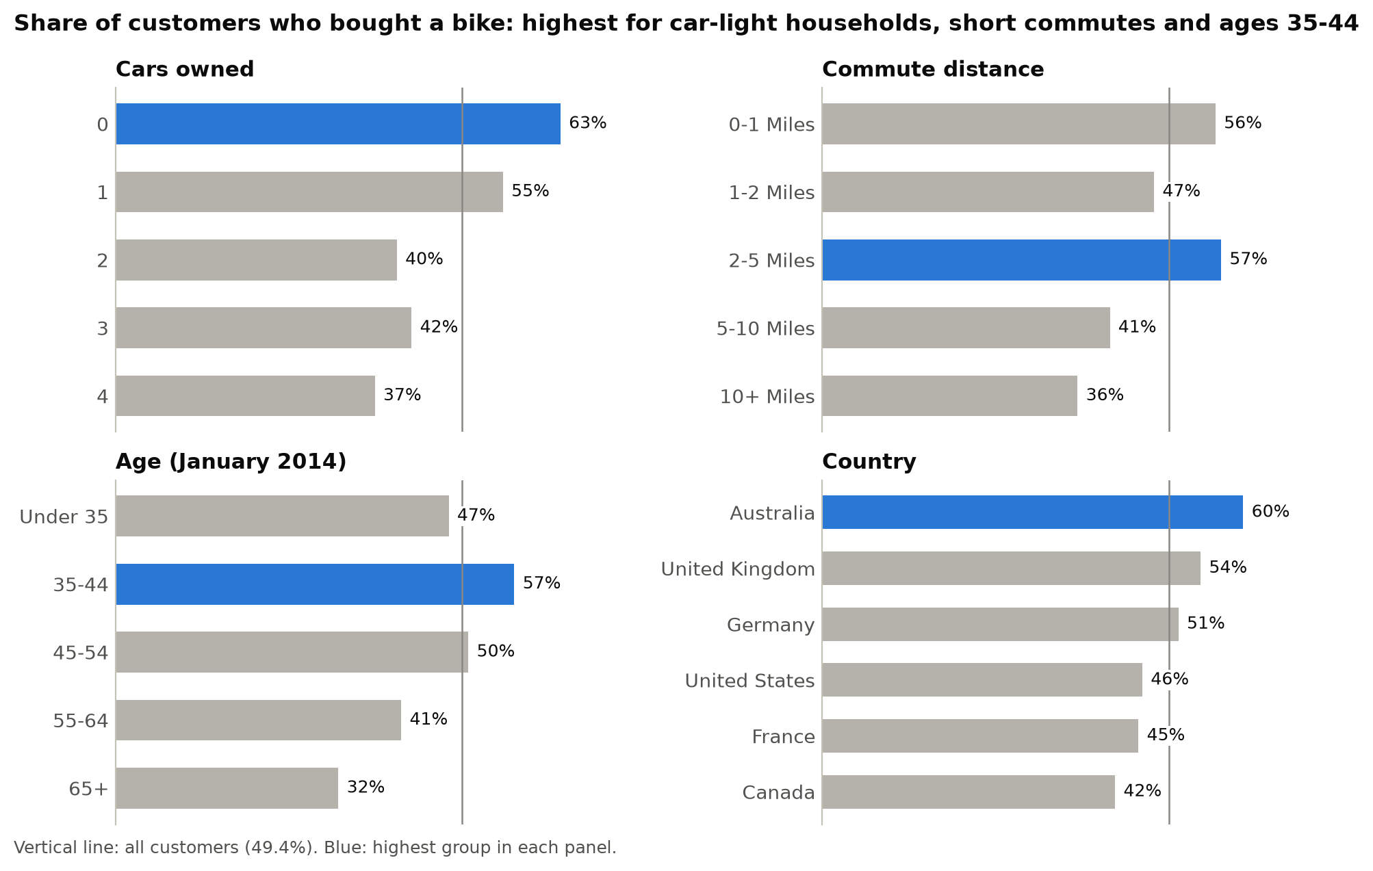
Fig. 4. Share of customers who bought a bike, by cars owned, commute distance, age in January 2014 and country region, with the vertical line at the rate for all customers (49.4%); author's chart from InternetSales.csv (Microsoft).
Bike buyers are concentrated among customers with no car (63%) or one car (55%), short commutes (56% for 0–1 mile and 57% for 2–5 miles), ages 35 to 44 (57%) and Australia (60%). Customers with four cars (37%), commutes over 10 miles (36%) or ages 65 and over (32%) rarely buy bikes. These traits, not home ownership, are the useful ones for targeting first-bike offers.

Appendix C: The Regression Behind the Home-Ownership Estimate
To separate home ownership from other customer traits, I regressed each customer's lifetime Internet sales on home ownership and the other traits in the file, using ordinary least squares (see table 10). The standard errors are heteroskedasticity-robust HC3 errors (MacKinnon and White), which stay reliable when the spread of spending differs between customers (Long and Ervin).
Table 10
Regression of Lifetime Internet Sales per Customer (US$), Selected Coefficients
Term | Coefficient | Robust standard error | p-value
Homeowner (vs. not) | 109.77 | 20.11 | <0.001
Yearly income (per $10,000) | 103.09 | 5.11 | <0.001
Cars owned (per car) | −70.56 | 10.90 | <0.001
Children living at home (per child) | −78.02 | 8.68 | <0.001
Total children (per child) | 26.26 | 7.64 | <0.001
Age (per year) | −3.45 | 0.85 | <0.001
Male (vs. female) | −23.22 | 16.04 | 0.148
Canada (vs. Australia) | −108.02 | 39.00 | 0.006
France (vs. Australia) | 259.96 | 47.22 | <0.001
Germany (vs. Australia) | 301.90 | 40.59 | <0.001
United Kingdom (vs. Australia) | 307.16 | 37.80 | <0.001
United States (vs. Australia) | −198.99 | 24.53 | <0.001
First purchase in 2011 (vs. 2010) | −274.87 | 478.04 | 0.565
First purchase in 2012 (vs. 2010) | −1,803.79 | 477.48 | <0.001
First purchase in 2013 (vs. 2010) | −4,892.30 | 476.82 | <0.001
First purchase in 2014 (vs. 2010) | −5,305.55 | 476.96 | <0.001
Source: Author's estimates from InternetSales.csv (Microsoft); n = 18,484 customers, R² = 0.738. The model also includes an intercept and indicators for marital status, education, occupation and commute distance; the full output is in section 8 of the notebook. Only 14 customers first bought in 2010, so the first-purchase terms have large standard errors.
Four results matter for this report:
- Home ownership adds little. Holding the other traits constant, a homeowner spends $109.77 more than an otherwise similar non-homeowner, less than the raw gap of $130.51.
- Purchase timing matters most. Customers who first bought in 2013 have spent about $4,600 less than otherwise similar customers who started in 2011, mainly because they have had less time to buy again.
- Income matters more than home ownership. Each extra $10,000 of yearly income goes with $103 more in lifetime sales, so a customer earning $100,000 has spent about $515 more than one earning $50,000. Gender makes no significant difference (p = 0.148).
- The model fits well. It explains 73.8% of the variation in lifetime sales between customers.

